Lesson 2: Drawing Shapes 🎨

1. Complete code
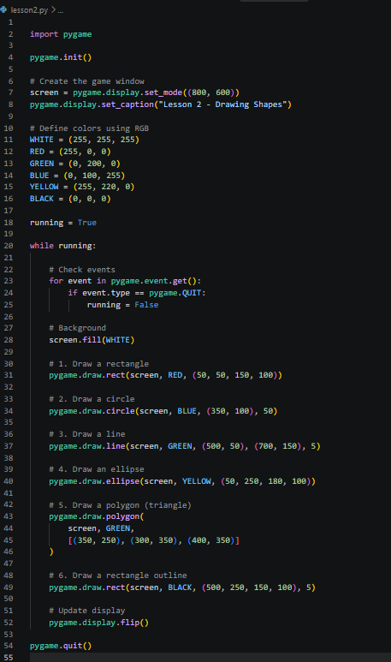
Create a file named lesson2.py and copy this code.
Run it using:
python lesson2.py
2. Understand each shape
A. Rectangle
pygame.draw.rect(screen, RED, (50, 50, 150, 100))
The values mean x-position, y-position, width, and height.
B. Circle
pygame.draw.circle(screen, BLUE, (350, 100), 50)
The values mean center x, center y, and radius.
C. Line
pygame.draw.line(screen, GREEN, (500, 50), (700, 150), 5)
The coordinates specify the start and end points. The last value is thickness.
D. Ellipse
pygame.draw.ellipse(screen, YELLOW, (50, 250, 180, 100))
An ellipse is an oval shape drawn inside a rectangle.

E. Polygon
pygame.draw.polygon(screen, GREEN, [(350,250), (300,350), (400,350)])
A polygon connects points to create shapes such as triangles.

3. Understand screen coordinates
Remember this rule: (0, 0) is the top-left corner of the window.
In an 800 × 600 window, x increases toward the right and y increases toward the bottom.
For example:
pygame.draw.circle(screen, RED, (400, 300), 50)
This draws a red circle at the center of an 800 × 600 window.

4. Practical challenge: Draw a car
Now let's use shapes to make a simple car!
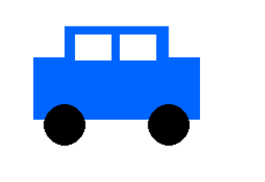
Add this code inside your game loop, after screen.fill(WHITE) and before pygame.display.flip(). Run the program. You've drawn a car using basic shapes.
